**Day 1**

* **History of Internet**
  + Who is Charles Babage
  + Why he is known as the father of computing
  + How internet works
  + Who is alan turing
  + Who invented WWW
  + What is the first browser
* **Know about Browser**
  + What is URL
  + How browser understands programing language
  + What is HTML
  + What is tags in HTML
  + What is meant by element
  + What is meant by Attribute
  + Explain Img Tag
  + What is SRC Attribute
  + What is relative Path and Absolute path
* **Task**
  + Explore tags in W3 school
  + Create your Resume

**Day 2**

* **HTML Forms**
  + Input Elements and Input Attributes
  + What are all the type attribute with ‘text’, ‘password’, ‘email’
  + Label Element
  + Submit Button
  + Radio Button
  + How to Group Radio Buttons
  + Check Box
  + File Uploader
  + Text Area
  + Select Box

**Day 3**

* Basics
  + Inline Style
  + Internal Style
  + External Style
  + Property and Value in CSS
  + Display : Block and Inline
  + Class and ID
  + CSS Hierarchy

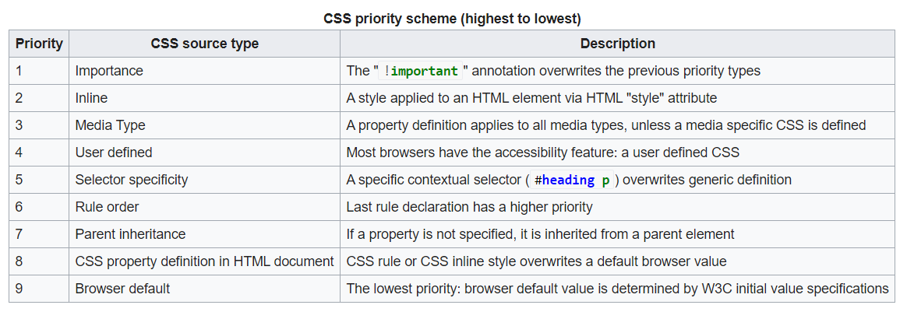

* Intermediate
  + Margin and Padding
  + Position Property
    - Static
    - Fixed
    - Relative
    - Absolute
    - Sticky
  + Clip
  + Gradient
  + Border Radius
  + Drop Shadow
  + How to Import Google web Fonts
  + Fontawesome
  + Difference between Pixel and Vector
  + Icons
  + What is Responsive design?
  + Media query

**Learn Flexbox**

<https://www.youtube.com/watch?v=K74l26pE4YA&t=16s>

<https://flexboxfroggy.com/>

**Day 4**

**Javascript**

* **Copy by reference**
* 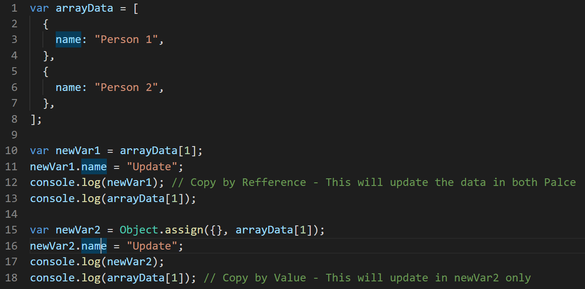
* Hoisting
* Array Advance Methods map(), filter(), find(), reduce()
* String Method split(),slice(),substr(),concat(),uppercase(),lowercase(),trim()